***WEEK 6 ASSIGNMENT***

**TOPIC :** Make a webpage using HTML on the topic 'NIELIT Imphal'.

**OBJECTIVES :**

1. Get a good understandingof using <**font**> tag. Such as usage of **size**, **face** and **color** inside the font tag.
2. Understanding HTML **list tags** such as Unordered list(<ul></ul>), Ordered list(<ol></ol>) and list(<li></li>). Also, the use of **type** attribute in <ul> or <ol> tags.
3. To get more familiar with the usage of <table> tag to organize data properly. Also, the attributes use in <table> tag such as **cellspacing**, **cellpadding**, **border**, **bgcolor**, etc.
4. To be more creative creating websites with limited tags, attributes and without using CSS.

**TECHNOLOGY USED** :

1. HTML (HyperText Markup Language)
2. HTML Lists (<ul>, <ol>, <li>)
3. HTML Tables (<table>)

**SOURCE CODE** :

<!DOCTYPE html>

<html>

<head>

<title>NIELIT Website</title>

</head>

<body bgcolor="#FFF5BA">

<table width="100%" bgcolor="yellow" cellspacing="0" cellpadding="10">

<tr>

<td align="center">

<font color="#27336e" face="arial" size="7px"><b>NIELIT</b></font><br>

<font size="4px">National Institute of Electronics & Information Technology, Imphal</font>

</td>

</tr>

</table>

<br>

<table width="100%" bgcolor="#074f7a" cellpadding="10" cellspacing="0">

<tr align="center">

<td><font face="arial" color="white">Home</font></td>

<td><font face="arial" color="white">About Us</font></td>

<td><font face="arial" color="white">Management</font></td>

<td><font face="arial" color="white">Services</font></td>

<td><font face="arial" color="white">Student Zone</font></td>

<td><font face="arial" color="white">News</font></td>

<td><font face="arial" color="white">Recruitment</font></td>

<td><font face="arial" color="white">Tenders/EoI</font></td>

<td><font face="arial" color="white">Contact Us</font></td>

<td><font face="arial" color="white">NIELIT HQ</font></td>

</tr>

</table>

<br>

<table width="100%">

<tr align="center">

<td>

<font size="6px" color="#654321" face="cursive"><b>Welcome to NIELIT IMPHAL's Website!</b></font>

</td>

</tr>

</table>

<br>

<table width="100%" cellpadding="10" cellspacing="10">

<tr>

<td bgcolor="#074f7a" colspan="2" align="center">

<font color="white" face="arial"><b>Latest News</b></font>

</td>

<td bgcolor="#074f7a" colspan="2" align="center">

<font color="white" face="arial"><b>Latest Events</b></font>

</td>

</tr>

<tr>

<td bgcolor="yellow" colspan="2">

<ul type="disc">

<li>Recruitment of Assistant Professor (Contract) - Walk-in Interview on 13/09/2024.</li>

<li>BCA June 2024 Entrance Test Result.</li>

<li>Webinar on Big Data & Hadoop - 28th November 2023.</li>

<li>One-day Mega Job Fair - 22nd November 2023.</li>

</ul>

</td>

<td bgcolor="yellow" colspan="2">

<ul type="square">

<li>Awareness Program on "Drone Flying Techniques".</li>

<li>5-day BOOTCAMP (5th Batch) on "Big Data & Data".</li>

<li>State Skill Mela Participation.</li>

<li>Corruption-Free India Initiative.</li>

<li>8-day Chemistry Training Program.</li>

</ul>

</td>

</tr>

</table>

<br>

<table width="100%" cellpadding="10">

<tr>

<td bgcolor="#074f7a" colspan="2" align="center">

<font color="white" face="arial"><b>About NIELIT</b></font>

</td>

</tr>

<tr>

<td bgcolor="yellow">

<ul type="circle">

<li>NIELIT Imphal was established in 1988 and has been operational since July 1989.</li>

<li>It is an autonomous scientific society under the Ministry of Electronics and IT, Govt. of India.</li>

<li>Specializes in skill development in Electronics & IT.</li>

</ul>

</td>

</tr>

</table>

<br>

<table width="100%" cellpadding="10">

<tr>

<td bgcolor="#074f7a" colspan="2" align="center">

<font color="white" face="arial"><b>Academic Programs</b></font>

</td>

<td bgcolor="#074f7a" colspan="2" align="center">

<font color="white" face="arial"><b>Training and Skill Development</b></font>

</td>

</tr>

<tr>

<td bgcolor="yellow" colspan="2">

<ol type="1">

<li>Diploma in Electronics & Communication Engineering (AICTE recognized)</li>

<li>Diploma in Computer Science & Engineering (AICTE recognized)</li>

<li>PGDCA, BCA, MCA, MSc.IT</li>

<li>NIELIT 'O' Level courses in IT and Hardware</li>

</ol>

</td>

<td bgcolor="yellow" colspan="2">

<ol type="I">

<li>Digital Literacy Awareness</li>

<li>Cyber Security and Cyber Forensics</li>

<li>Embedded Systems & IoT</li>

<li>Big Data Analytics</li>

<li>Computer Networking & Security</li>

</ol>

</td>

</tr>

</table>

<br><br>

<table width="100%" bgcolor="#074f7a" cellpadding="10">

<tr align="center">

<td><font color="white"><b>Explore NIELIT</b></font></td>

<td><font color="white"><b>Website Policies</b></font></td>

<td><font color="white"><b>Useful Links</b></font></td>

<td><font color="white"><b>Online Services</b></font></td>

</tr>

<tr align="center">

<td><font color="white">Act and Rules | RTI | Vigilance | Grievance | Holiday Calendar</font></td>

<td><font color="white">COVID Compliance | Privacy Policy | Terms & Conditions</font></td>

<td><font color="white">meity.gov.in | india.gov.in | mygov.in | AICTE</font></td>

<td><font color="white">Registration | Examination | Accreditation | Recruitments</font></td>

</tr>

</table>

</body>

</html>

**OUTPUT** :

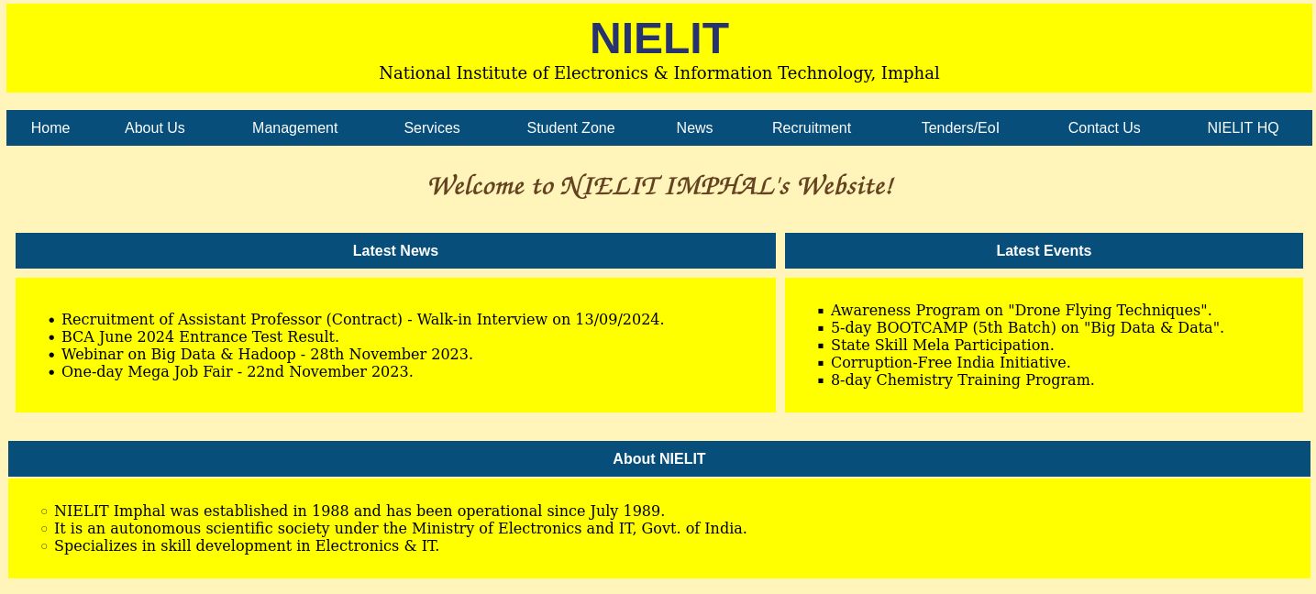

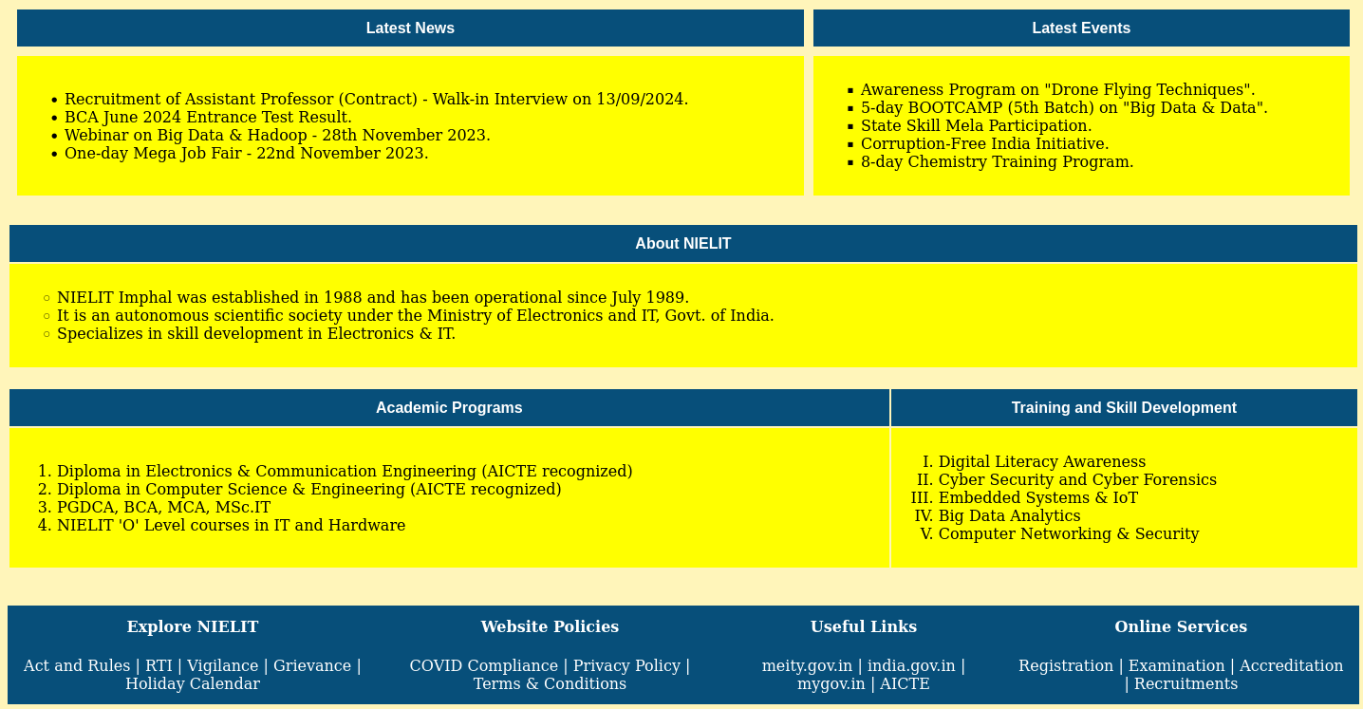

**SUBMITTED BY** :

ABHINASH TOIJAM

ROLL NO. - BC 1953

SEC - A

BCA 4th SEMESTER